

JAVA PROGRAMMING LAB FILE
IT201

NAME-

COURSE-

ENROLLMENT N0.-

INDEX

S.NO | TITLE | DATE | SIGN
01 | Fibonacci series | 15-9-2021
02 | Bubble sort method | 17-9-2021
03 | Binary search | 20-9-2021
04 | Matrix Average | 20-9-2021
05 | Train | 20-9-2021
06 | Constructor overloading | 23-9-2021
07 | Overloading and overriding | 25-9-2021
08 | Employee class | 27-9-2021
09 | Checkpaland | 27-9-2021
10 | Dimensions class | 27-9-2021
11 | Figure class | 27-9-2021
12 | Exception handling | 1-10-2021
13 | Exception handling | 2-10-2021
14 | Login Window | 2-10-2021
15 | Marksheet | 4-10-2021
16 | Keyword sorting | 4-10-2021
17 | Mouse handler | 4-10-2021
18 | Mathematical Operations | 7-10-2021
19 | Runnable interface | 10-10-2021
20 | Thread class | 12-10-2021
21 | Border button layout | 13-10-2021

Question 1) Write a program to generate Fibonacci series
Code:

public class Fibo {
public static void main(String args[])
{
int n1=0,n2=1,n3,i,count=10;
System.out.print(n1+" "+n2);
for(i=0;i<count;i++)
{
n3=n1+n2;
System.out.print(" "+n3);
n1=n2;
n2=n3;
}

}
}

Output :

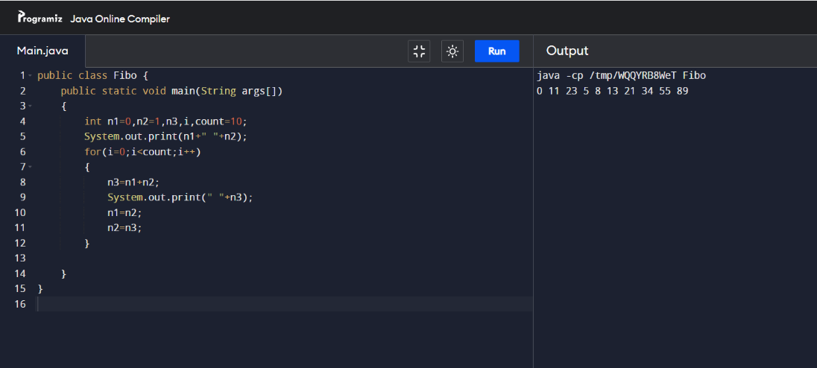
Question 2) Write a program to sort the following numbers in an array using Bubble Sort Method. Display the contents of the sorted array.
Code:

class BubbleSort
{
void bubbleSort(int arr[])
{
int n = arr.length;
for (int i = 0; i < n-1; i++)
for (int j = 0; j < n-i-1; j++)
if (arr[j] > arr[j+1])
{
int temp = arr[j];
arr[j] = arr[j+1];
arr[j+1] = temp;
}
}
void printArray(int arr[])
{
int n = arr.length;
for (int i=0; i<n; ++i)
System.out.print(arr[i] + " ");
System.out.println();
}

public static void main(String args[])
{
BubbleSort ob = new BubbleSort();
int arr[] = {64, 34, 25, 12, 22, 11, 90};
ob.bubbleSort(arr);
System.out.println("Sorted array");
ob.printArray(arr);
}
}

Output :

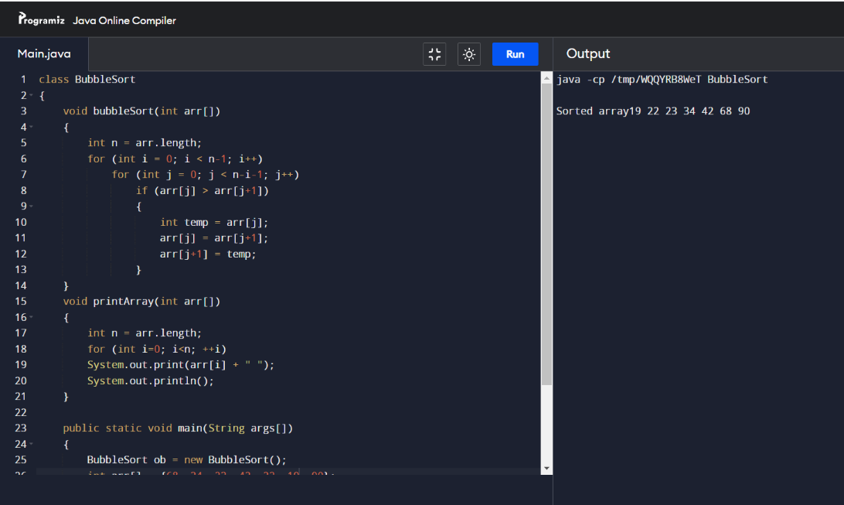

Question 3) Write a program for Binary Search in Java.
Code:

class BinarySearchExample{
public static void binarySearch(int arr[], int first, int last, int key){
int mid = (first + last)/2;
while( first <= last ){
if ( arr[mid] < key ){
first = mid + 1;
}else if ( arr[mid] == key ){
System.out.println("Element is found at index: " + mid);
break;
}else{
last = mid - 1;
}
mid = (first + last)/2;
}
if ( first > last ){
System.out.println("Element is not found!");
}
}
public static void main(String args[]){
int arr[] = {10,20,30,40,50};
int key = 30;
int last=arr.length-1;
binarySearch(arr,0,last,key);
}
}

Output :

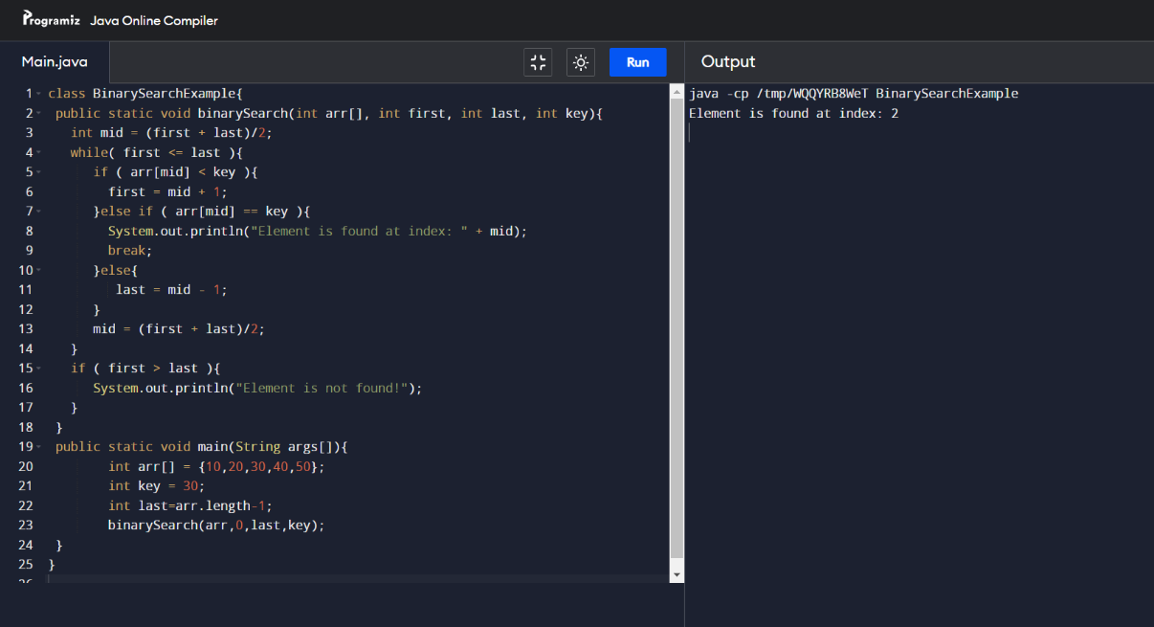

Question 4) Write a program to read a n*m matrix and find:
- The average of each row
- The average of each column
- The average of all the entries
Code:

import java.io.*;

class GFG {

static int m = 4;
static int n = 4;

static void row_sum(int arr[][])
{
int i, j, sum = 0;
System.out.print("\nFinding Sum of each row:\n\n");
for (i = 0; i < m; ++i) {
for (j = 0; j < n; ++j) {
sum = sum + arr[i][j];
}
System.out.println("Sum of the row " + i + " = "+ sum/m);
sum=0;
}
}
static void column_sum(int arr[][])
{
int i, j, sum = 0;
System.out.print("\nFinding Sum of each column:\n\n");
for (i = 0; i < m; ++i) {
for (j = 0; j < n; ++j) {
sum = sum + arr[j][i];
}
System.out.println("Average of the column " + i + " = " + sum/n);
sum=0;
}
}
static void each_sum(int arr[][])
{
int i, j, sum = 0;
System.out.print("\nFinding Sum of each column:\n\n");
for (i = 0; i < m; ++i) {
for (j = 0; j < n; ++j) {
sum = sum + arr[j][i];
}
}
System.out.println("Average of the matrix = " + sum/(n*m));
}
public static void main(String[] args)
{
int i, j;
int[][] arr = new int[m][n];
int x = 1;
for (i = 0; i < m; i++)
for (j = 0; j < n; j++)
arr[i][j] = x++;
row_sum(arr);
column_sum(arr);
each_sum(arr);
}
}

Output :

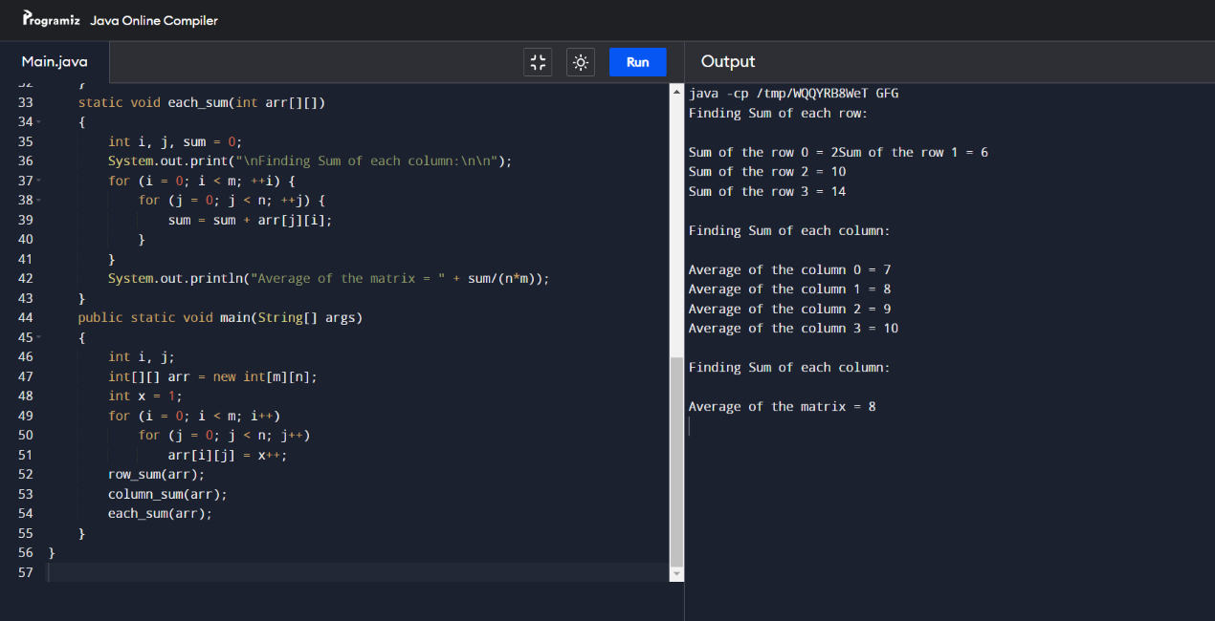

.

Question 5) Define a class called TRAIN with the following attributes.
- Train No.
- Starting point of the travel
- Destination of travel
- Date and Time of departure from starting point
- Date and Time of arrival at the destination
- Total number of seats

Develop a suitable constructor and define a method for printing the details of a train. Create two objects and print all the details of train.
Code:

public class Train {

int no;
String start;
String dest;
String adate, atime;
String ddate, dtime;
int seats;

public Train(int n, String st, String d, String ad, String at, String dd, String dt,int s){
no = n;
start = st ;
dest = d;
adate = ad;
atime= at;
ddate = dd;
dtime =dt;
seats =s;
}
void detail(){
System.out.println("");
System.out.println("");
System.out.println("Train No. "+no);
System.out.println("Start Location : "+start);
System.out.println("Destination : "+dest);
System.out.println("Departure Date :"+ddate);
System.out.println("Departure Time : "+dtime);
System.out.println("Arrival Date : "+adate);
System.out.println("Arrival Time : "+atime);
System.out.println("No. of Seats : "+seats);
System.out.println("");
System.out.println("");
}

public static void main(String[] args) {
int n,se;
String s,d,dd,dt,ad,at;
n = 25063;
s = "Lucknow";
d = "Delhi";
dd= "14 Aug, 2021.";
dt= "01:15 PM";
ad= "15 Aug, 2021.";
at= "12:59 PM";
se= 15000;
Train tr = new Train(n,s,d,dd,dt,ad,at,se);
tr.detail();
n = 25000;
s = "Kashmir";
d = "Kanyakumari";
dd= "20 Aug, 2021.";
dt= "05:15 PM";
ad= "30 Aug, 2021.";
at= "12:00 AM";
se= 100000;
Train tr1 = new Train(n,s,d,dd,dt,ad,at,se);
tr1.detail();
}
}

Output :

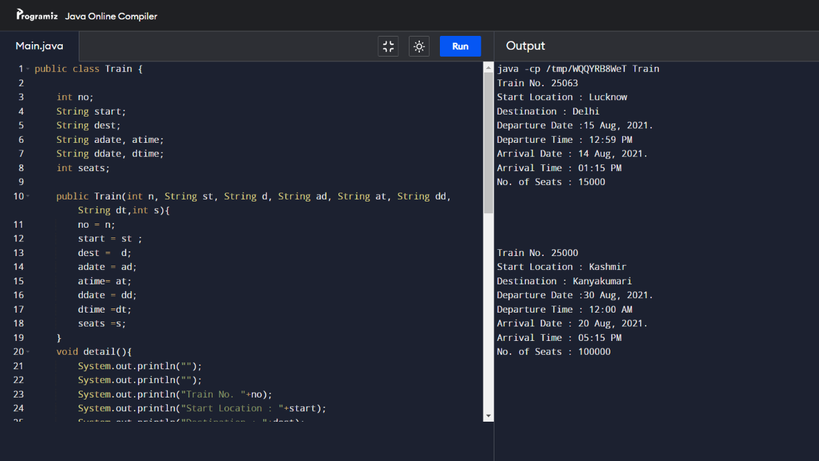

Question 6) Write a program in JAVA for constructor overloading. (Show the usage of all types of constructors)
Code:

class Student {
int id;
String name;

Student(){
System.out.println("this a default constructor");
}

Student(int i, String n){
id = i;
name = n;
}

public static void main(String[] args) {
Student s = new Student();
System.out.println("\nDefault Constructor values: \n");
System.out.println("Student Id : "+s.id + "\nStudent Name : "+s.name);

System.out.println("\nParameterized Constructor values: \n");
Student student = new Student(10, "David");
System.out.println("Student Id : "+student.id + "\nStudent Name : "+student.name);
}
}

Output :

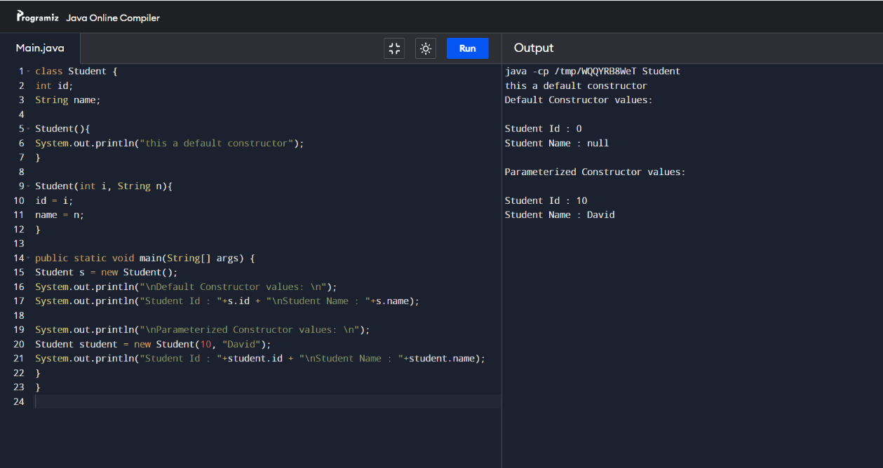

Question 7) Write a program in Java to implement overloading and overriding.
Code:

class Parent
{
int add(int a, int b)
{
return (a + b);
}
int add(int a , int b , int c)
{
return (a + b + c) ;
}
double add(double a , double b)
{
return (a + b);
}
double add(int a , double b)
{
return (a + b);
}
void view()
{
System.out.println("for overridding");
}
}
class Child extends Parent{
@Override
void view()
{
System.out.println("This is a child class method");
}
}
class MethodOverriding
{
public static void main(String args[])
{
Parent ob = new Parent();
System.out.println("Calling add method with two int parameters: " +ob.add(17, 25));
System.out.println("Calling add method with three int parameters: " +ob.add(55, 27, 35));
System.out.println("Calling add method with two double parameters: " +ob.add(36.5, 42.8));
System.out.println("Calling add method with one int and one double parameter: " +ob.add(11, 24.5));
ob.view();
Parent obj1 = new Child();
obj1.view();
}
}

Output :

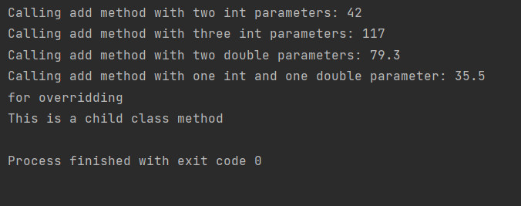

Question 8) Create a class called Employee that will have the following attributes:
- Employee Number
- Name
- Address
- Date of Birth
- Date of Joining
The class must have the following methods also:
- A constructor that accepts nothing and initializes all numeric attributes with 0 and string with null
- A constructor that accepts all attributes values.
- A method called display that display all attributes.
Create two subclasses of Employee class called Wagers and Salaried. The Salaried should have additional attributes as basic salary, da, hra, and pf. Whereas Wagers should have additional attributes as hoursworked, perhourpayment. Both the subclasses should have display method and that should display the employee details as well as the type of employee (Salaried or Wager).
Write a main program to
- Test the methods of Employee class.
- Test the display() method of all three classes.
- Create an object of Salaried class and another object of Employee class. Type cast the object of Salaried class to an object of Employee Class
Code:

import java.util.Scanner;

public class Employee {
int em;
String name;
String Address;
String dob;
String doj;

public Employee()
{
em = 0;
name = "";
Address = "";
dob = "";
doj = "";
}
public Employee(int e, String n, String a, String b, String j)
{
em = e;
name = n;
Address = a;
dob = b;
doj = j;
}
void display()
{
System.out.println();
System.out.println("Employee No. "+em);
System.out.println("Name : "+name);
System.out.println("Address : "+Address);
System.out.println("Date of Birth : "+dob);
System.out.println("Date of Joining : "+doj);
System.out.println();
}
}
class Salaried extends Employee
{
double basic;
double hra, pf, da;
double net;
void input()
{
Scanner sc = new Scanner(System.in);

System.out.println("Enter Basic Salary, HRA, PF, DA respectively ");
basic = sc.nextDouble();
hra = sc.nextDouble();
pf = sc.nextDouble();
da = sc.nextDouble();
}
void cal()
{
net = (basic + hra + da) - pf ;
}
void display()
{
System.out.println("Net Salary is : "+net);
}
}
class Wagers extends Employee
{
int hoursworked, perhourpayment;
void display()
{
System.out.println("Attributes ka karu kya??");
}
}
class Test{
public static void main(String[] args) {
Employee obj1 = new Employee();
Employee obj2 = new Employee(102, "USER", "North Korea", "08, july 2001", " 25,sep 2020");
obj2.display();
Salaried obj3 = new Salaried();
obj3.input();
obj3.cal();
obj3.display();
Wagers obj4 = new Wagers();
obj4.display();
}
}

Output :

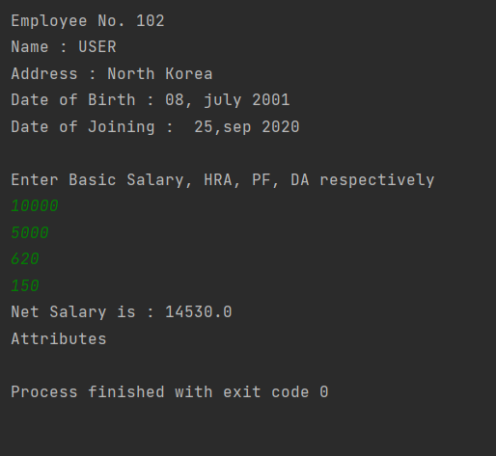

Question 9) Create a class named CheckPalind that has two constructors with different signatures. One will accept only single string parameter and another accepts two string parameters. You have to create a method to check whether a string is a palindrome or not. If a single parameter constructor is called, that string will be checked as it is. If the constructor with two parameters is called it should first concatenate the string and then check the concatenated string whether it is a palindrome or not.
Code:

public class CheckPalind {
String s1;
String s2;
String s3;

public CheckPalind(String a)
{
s1 = a;
}
public CheckPalind(String b, String c)
{
s2 = b;
s3 = c;
}
void display()
{
String str = "";
for(int i = s1.length()-1;i>=0;i--)
{
str = str + s1.charAt(i);
}
if ( str.equals(s1))
{
System.out.println("String is a Palindrome");
}
else
{
System.out.println("String is not a Palindrome");
}
}
void display2()
{
String str = "";
String c = s2.concat(s3);

System.out.println("Concatenated String : "+c);

for(int i = c.length()-1; i>=0; i--)
{
str = str + c.charAt(i);
}
if ( str.equals(c))
{
System.out.println("String is a Palindrome");
}
else
{
System.out.println("String is not a Palindrome");
}
}
public static void main(String[] args) {
CheckPalind obj1 = new CheckPalind("madam");
obj1.display();
CheckPalind obj2 = new CheckPalind("world","hello");
obj2.display2();
}
}

Output :

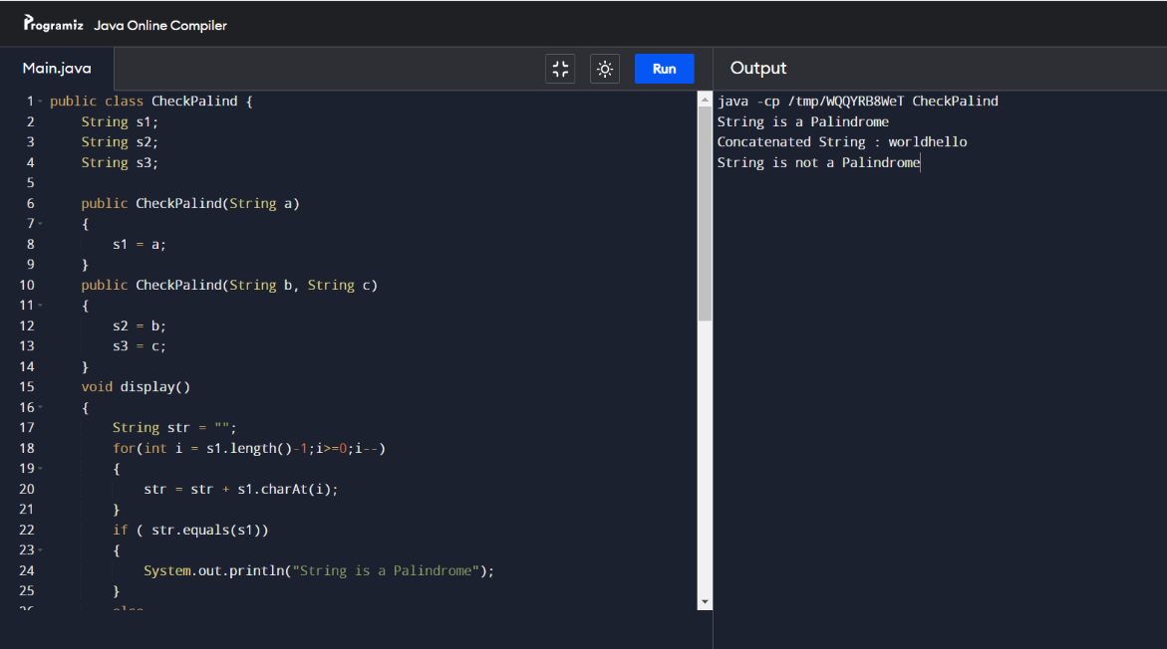

Question 10) Write a program that creates an abstract class called dimension, creates two subclasses, rectangle and triangle. Include appropriate methods for both the subclasses that calculate and display the area of the rectangle and triangle.
Code:

abstract class Dimension {
abstract void calculate();
abstract void display();

}
class Rectangle extends Dimension
{
int l,b;
double area;
void calculate()
{
l = 10;
b = 20;
area = l*b;
}
void display()
{
System.out.println("The Area of Rectangle is : "+area);
}
}
class Triangle extends Dimension
{
int b, h;
double area;
void calculate()
{
b = 10;
h = 15;
area = 0.5 * b * h;
}
void display()
{
System.out.println("The Area of Triangle is : "+area);
}

}
class Test{
public static void main(String[] args) {
Dimension obj = new Rectangle();
obj.calculate();
obj.display();
Dimension obj1 = new Triangle();
obj1.calculate();
obj1.display();
}
}

Output :

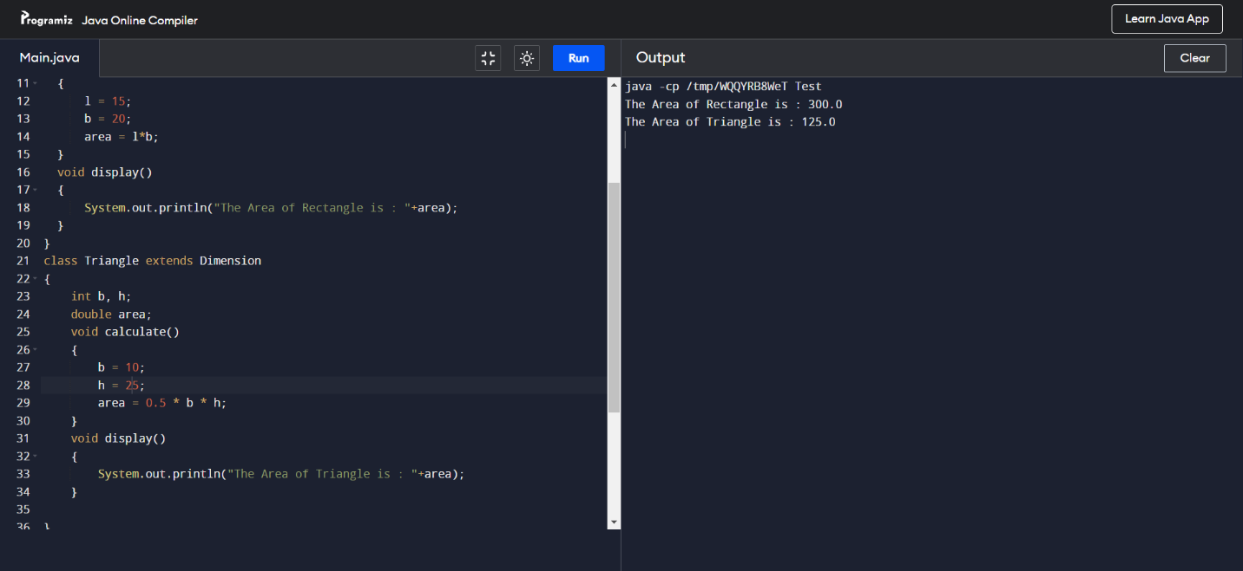
Question 11) Create an abstract class called Figure that has an abstract method called draw (). Make the subclasses called Filled_Rectangle, Filled_Arc and override the draw method in which you would print the message regarding the current object.
Code:

abstract class Figure {
abstract void draw();
}
class Filled_Arc extends Figure
{
void draw()
{
System.out.println("Hii!!");
}
}
class Filled_Rectangle extends Figure
{
void draw()
{
System.out.println("Hello");
}
}
class Test{
public static void main(String[] args) {
Figure obj = new Filled_Arc();
obj.draw();
Figure obj1 = new Filled_Rectangle();
obj1.draw();
}
}

Output :

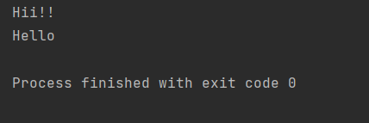

Question 12) Write a Java program that accepts two strings as command line arguments. It checks for the number of command line arguments. If they are less or more it throws an exception giving an appropriate message.
Code:

import java.lang.Exception;
class Exp extends Exception
{
Exp(String msg)
{
super(msg);
}
}

class test_argument
{
public static void main(String args[])
{

String string;

try
{
int count, i=0;

count=args.length;
System.out.println("Number of Arguments are: = " +count);
if(count<2)
{
Exp ex=new Exp("Line Arguments are less!");
throw ex;
}
else if(count>2)
{
Exp ex=new Exp("Line Arguments are more!");
throw ex;
}
while(i<count)
{
string = args[i];
i=i+1;
System.out.println(i + ":" + "Number of Entered Arguments: " + string+ "!");
}
}
catch(Exp ex)
{
System.out.println(ex.getMessage());
}
}
}

Output :

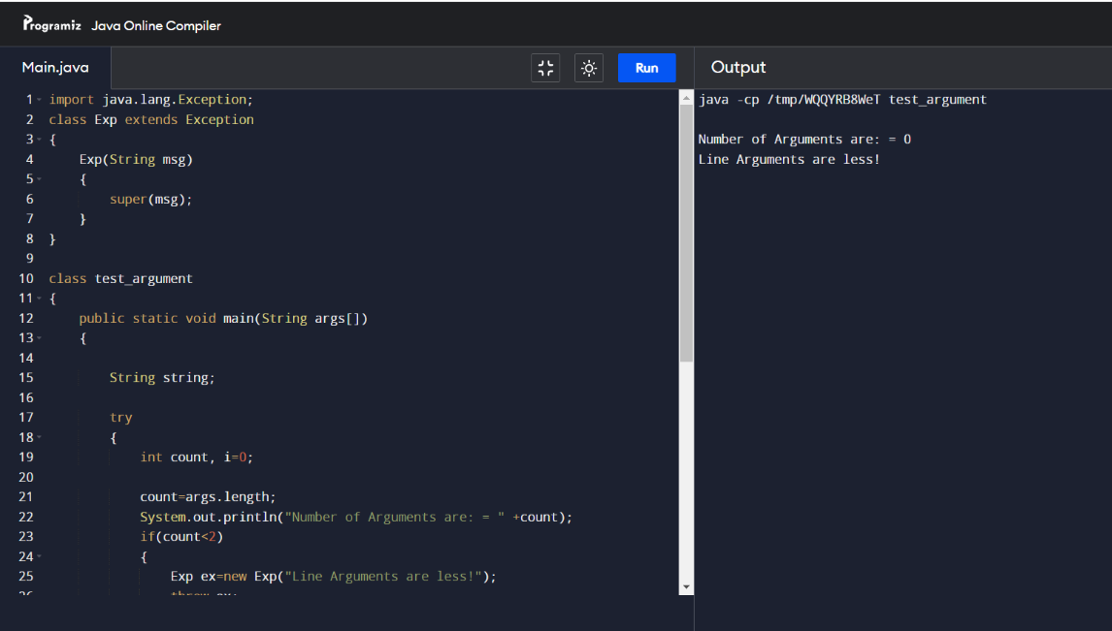
Question 13) write a program to handle arrayIndexoutofBoundsException

class ArrayIndexOutOfBoundException {
public static void main(String[] args) {
String[] arr = {"Ross","Shiv","Virus","Dan"};
for(int i=0;i<=arr.length;i++) {
System.out.println(arr[i]);
}

}
}
Output :

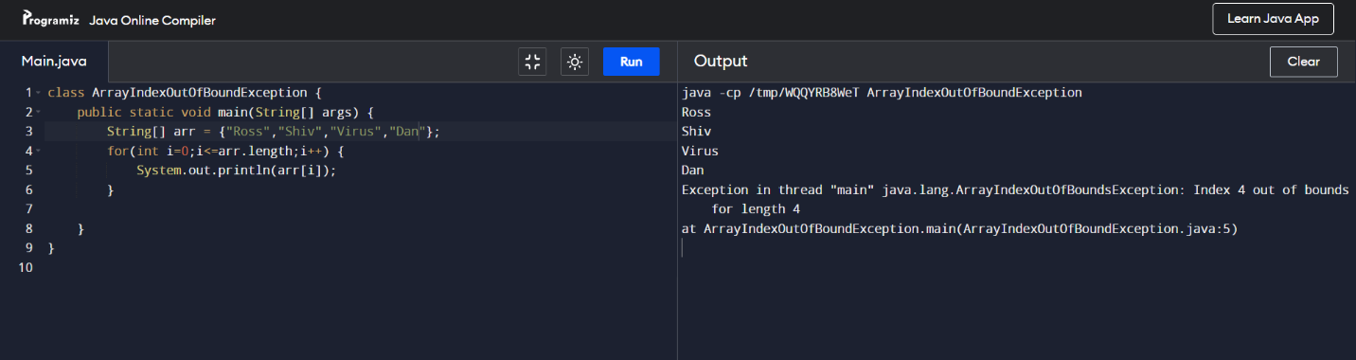

Question 14) Write a program to design login window using awt controls button label textfield.
Code:

import java.awt.*;
import java.awt.event.*;
class MyLoginWindow extends Frame
{
TextField name,pass;
Button b1,b2;
MyLoginWindow()
{
setLayout(new FlowLayout());
this.setLayout(null);
Label n=new Label("Name:",Label.CENTER);
Label p=new Label("password:",Label.CENTER);
name=new TextField(20);
pass=new TextField(20);
pass.setEchoChar('#');
b1=new Button("submit");
b2=new Button("cancel");
this.add(n);
this.add(name);
this.add(p);
this.add(pass);
this.add(b1);
this.add(b2);
n.setBounds(70,90,90,60);
p.setBounds(70,130,90,60);
name.setBounds(200,100,90,20);
pass.setBounds(200,140,90,20);
b1.setBounds(100,260,70,40);
b2.setBounds(180,260,70,40);

}
public static void main(String args[])
{
MyLoginWindow ml=new MyLoginWindow();
ml.setVisible(true);
ml.setSize(400,400);
ml.setTitle("my login window");

}
}

Output :

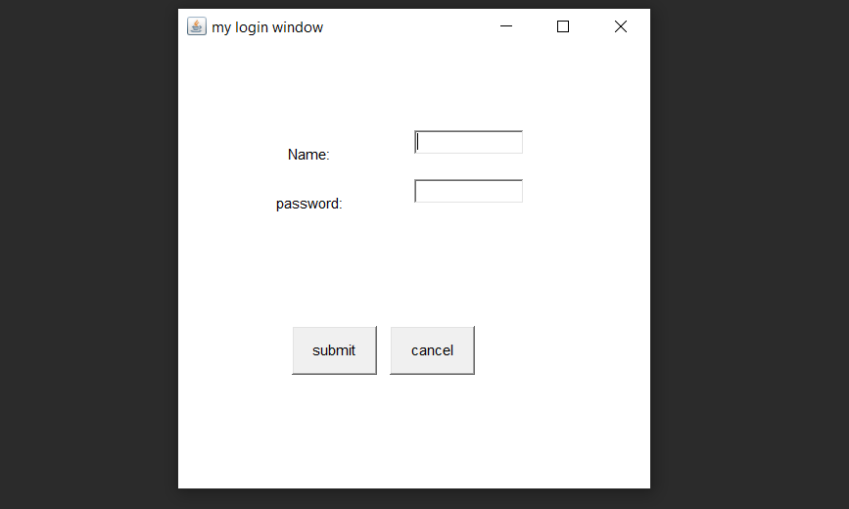

Question 15) Write a java program to generate marksheet of a student. Use following in your program :
- Class
- Object
- Constructors
Code:
import java.util.*;
class marksheet{
int m1, m2, m3, m4, total, roll;
double per;
String name;
public marksheet(){
m1=0;
m2=0;
m3=0;
m4=0;
total=0;
per=0.0;
roll=0;
name = "";
}
void input(){
Scanner sc = new Scanner(System.in);
System.out.println("Enter name, roll number and marks in 4 subjects. ");
name = sc.nextLine();
roll = sc.nextInt();
m1 = sc.nextInt();
m2 = sc.nextInt();
m3 = sc.nextInt();
m4 = sc.nextInt();
}
void calc(){
total = m1 + m2 + m3 + m4;
per = (total*100)/400;
}
void display(){
System.out.println("Name:- "+ name);
System.out.println("Roll number:- "+ roll);
System.out.println("Maths:- "+ m1);
System.out.println("Science:- "+ m2);
System.out.println("English:- "+ m3);
System.out.println("Computer:- "+ m4);
System.out.println("Total Marks:- "+ total);
System.out.println("Percentage:- "+ per);
}
public static void main(String[] args){
marksheet obj = new marksheet();
obj.input();
obj.calc();
obj.display();
}
}

Output :

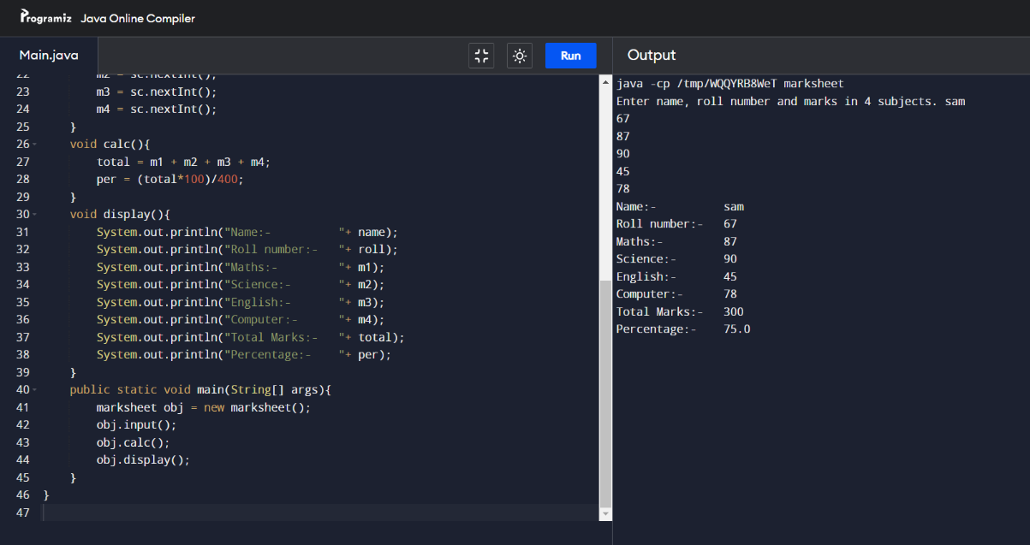

Question 16) Write a program to sort java keywords
Code:
import java.util.Arrays;
class Key
{
public static void main(String args[])
{
String[] words = {"class", "abstract", "boolean", "double", "static","continue"};
Arrays.sort(words);
System.out.print(Arrays.toString(words));
}
}
Output :
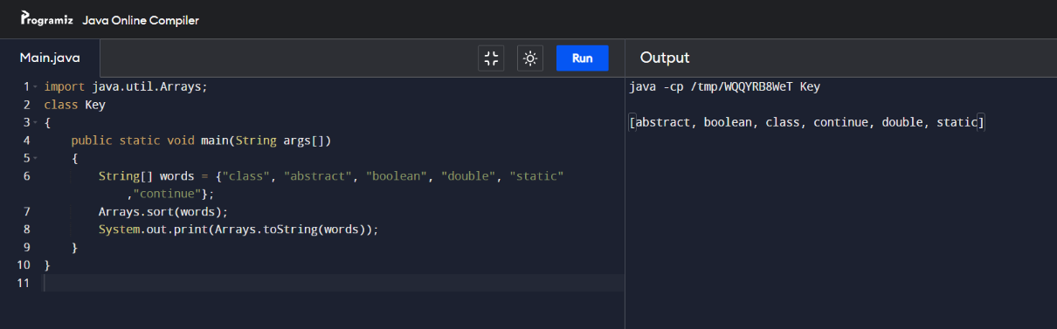

Question 17) Write a program to design a window using awt controls for mousehandler.
Code:

import java.awt.event.*;
import javax.swing. *;

class mouseHandler implements MouseMotionListener
{
public void mouseMoved(MouseEvent me) {
int x = me.getX();
int y = me.getY();
System.out.println("Mouse Move Event: (" + x + "," + y + ")");
}
public void mouseDragged(MouseEvent me)
{
int x = me.getX();
int y = me.getY();
System.out.println("Mouse Dragg Event: (" + x + "," + y + ")");
}
public static void main(String arg[])
{
JFrame jf = new JFrame("Event");
jf.setSize(400, 400);
jf.setDefaultCloseOperation(JFrame.EXIT_ON_CLOSE);
jf.addMouseMotionListener(new mouseHandler());
jf.setVisible(true);
}
}

Output :

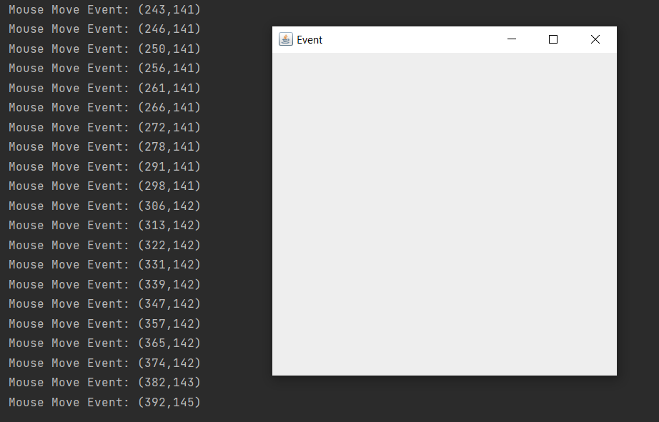

Question 18) Write a program to perform mathematical operations. Create a class called AddSub with methods to add and subtract. Create another class called MultDiv that extends from AddSub class to use the member data of the superclass. MultDiv should have methods to multiply and divide. A main method should access the method and perform the mathematical operations.
Code:

class AddSub
{ int num1;
int num2;
AddSub(int n1, int n2)
{
num1 = n1;
num2 = n2;
}
int add()
{
return num1+num2;
}
int sub()
{
return num1-num2;

}
}
class MultDiv extends AddSub
{
public MultDiv(int n1, int n2)
{
super(n1, n2);
}
int mul()
{
return num1*num2;
}
float div()
{
return num2/num1;
}
public void display()
{
System.out.println("Number 1 :" + num1);
System.out.println("Number 2 :" + num2);
}
}

class test
{
public static void main(String arg[])
{
AddSub r1=new AddSub(40,20);
int ad = r1.add();
int sb = r1.sub();
System.out.println("Addition =" +ad);
System.out.println("Subtraction =" +sb);
MultDiv r2 =new MultDiv(2,20);
int ml = r2.mul();
float dv =r2.div();
System.out.println("Multiply =" +ml);
System.out.println("Division =" +dv);
}
}

Output :

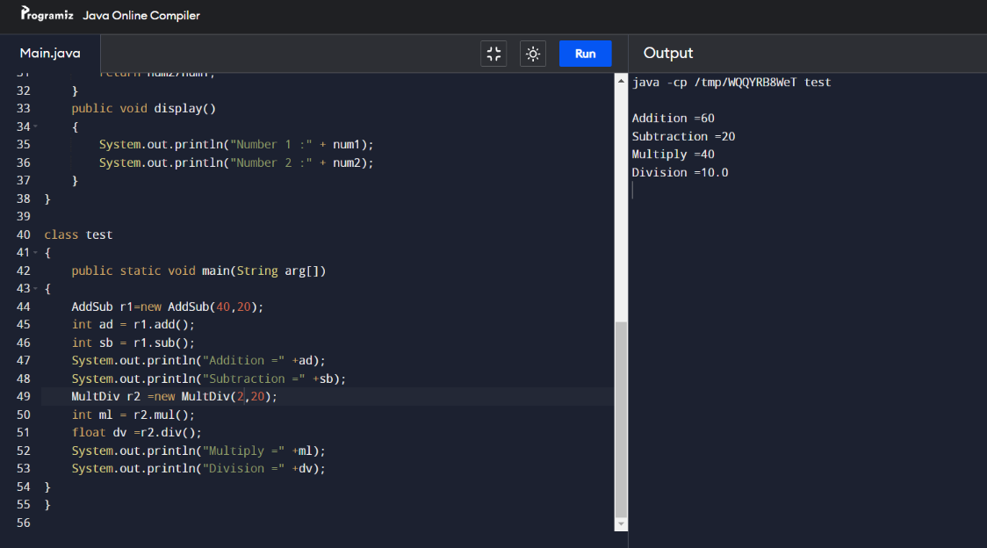

Question 19) Write a program to create 5 threads by implementing runnable interface.
Code:

class MyRunnable implements Runnable{
private int a;
public MyRunnable(int a){
this.a = a;
}
public void run(){
for (int i = 1; i <= a; ++i){
System.out.println(Thread.currentThread().getName() + " is " + i);
try{
Thread.sleep(1000);
}
catch (InterruptedException e){}
}
}
}
class MainMyThread{
public static void main(String args[]){
MyRunnable thr1, thr2;
thr1 = new MyRunnable(5);
thr2 = new MyRunnable(10);
Thread t1 = new Thread(thr1);
Thread t2 = new Thread(thr2);
t1.start();
t2.start();
}
}

Output :

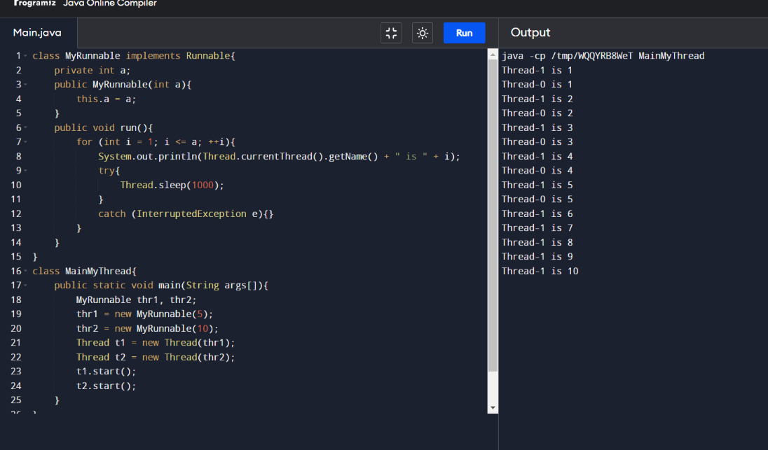

Question 20) Write a program to create 5 threads by extending threads class.
Code:

class A extends Thread
{
public void run()
{
for(int i=1; i<=2; i++)
{
System.out.println("\t From Thread A: i = " +i);
}
System.out.println("Exit from A");
}
}

class B extends Thread
{
public void run()
{
for(int j=1; j<=2; j++)
{
System.out.println("\t From Thread B: j = " +j);
}
System.out.println("Exit from B");
}
}

class C extends Thread
{
public void run()
{
for(int k=1; k<=2; k++)
{
System.out.println("\t From Thread C: k = " +k);
}
System.out.println("Exit from C");
}
}

class D extends Thread
{
public void run()
{
for(int m=1; m<=2; m++)
{
System.out.println("\t From Thread D: m = " +m);
}
System.out.println("Exit from D");
}
}

class E extends Thread
{
public void run()
{
for(int n=1; n<=2; n++)
{
System.out.println("\t From Thread E: n = " +n);
}
System.out.println("Exit from E");
}
}

class ThreadTest
{
public static void main(String args[])
{
new A().start();
new B().start();
new C().start();
new D().start();
new E().start();
}
}

Output :

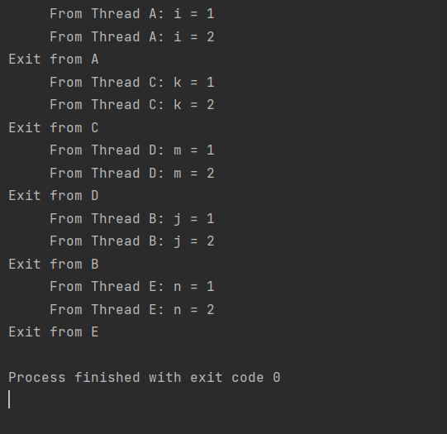

Question 21) Write a program using awt to illustrate Border layout.
Code:

import java.awt.*;
import java.awt.event.*;
import javax.swing.*;

class BoderLayoutDemo extends JFrame {
BoderLayoutDemo()
{
JPanel pa = new JPanel();
pa.setLayout(new BorderLayout());
pa.add(new JButton("Welcome"), BorderLayout.NORTH);
pa.add(new JButton("to"), BorderLayout.SOUTH);
pa.add(new JButton("my"), BorderLayout.EAST);
pa.add(new JButton("Java"), BorderLayout.WEST);
pa.add(new JButton("Lab File"), BorderLayout.CENTER);
add(pa);
setDefaultCloseOperation(JFrame.EXIT_ON_CLOSE);
setSize(300, 300);
setVisible(true);
}
}

class MainFrame {
public static void main(String[] args)
{
new BoderLayoutDemo();
}
}

Output :

